Chapter 12 (24)

Aggregate Demand and Aggregate Supply Analysis

SOLUTIONS TO END-OF-CHAPTER EXERCISES

Chapter 12 (24)

Answers to Thinking Critically Questions

- A fall in the value of the U.S. dollar relative to the values of other currencies makes U.S. exports less expensive in foreign markets. This will increase the demand for U.S. exports, which will shift the aggregate demand curve further to the right. The weaker U.S. dollar will also make imports to the U.S. more expensive, and the demand for imports will decrease. The decrease in demand for imports will also shift aggregate demand further to the right.

- If a company like UPS is geographically diversified, a slowing U.S. economy will have a smaller impact on its earnings than if its business was conducted entirely within the United States. A decline in earnings due to a slowing U.S. economy could be partially offset by increased business in countries with growing economies.

Learning Objective

Learning Objective 12.1: Identify the determinants of aggregate demand and distinguish between a movement along the aggregate demand curve and a shift of the curve.

Review Questions

1.1 The three reasons are the wealth effect, the interest-rate effect, and the international-trade effect. In the wealth effect, an increase in the price level decreases the real value of household wealth, which decreases consumption. In the interest-rate effect, an increase in the price level raises interest rates, which decreases investment spending and consumption spending, particularly on durable goods. In the international-trade effect, an increase in the price level makes U.S. exports more expensive and foreign imports less expensive, which decreases net exports.

1.2 The aggregate demand curve shows the relationship between the price level and the quantity of real GDP demanded by households, firms and the government. The demand curve for an individual product, such as apples, shows the relationship between the price of the individual product and the quantity of that product being demanded in the marketplace. With the demand curve for apples, as the price of apples rises, the prices of other products are held constant. As the price of apples rises, apples become more expensive relative to other products, so consumers buy fewer apples and more of other products. But the aggregate demand curve applies to the economy as a whole, so no substitution to other products is possible. The macroeconomic explanation of why the demand curve slopes downward is given in the answer to problem 1.1. The macroeconomic explanation does not involve substituting from one product to another.

1.3 The variables that will cause the aggregate demand curve to shift are interest rates, government purchases, personal income taxes or business taxes, household expectations of future incomes, firm expectations of the future profitability of investment spending, the growth rate of domestic GDP relative to the growth rate of foreign GDP, and the exchange rate value of the dollar. Increases in government purchases, household expectations of their future incomes, and firm expectations of the future profitability of investment spending will cause the aggregate demand curve to shift right. Increases in interest rates, personal income taxes or business taxes, growth rate of domestic GDP relative to the growth rate of foreign GDP, and the exchange rate value of the dollar will cause the aggregate demand curve to shift left.
Problems and Applications

1.4 a. An increase in the price level would cause a movement along the aggregate demand curve.
b. An increase in government purchases would cause the aggregate demand curve to shift to the right.
c. Higher state income taxes would decrease disposable income, thereby decreasing consumption spending, and causing the aggregate demand curve to shift to the left.
d. Higher interest rates would decrease investment spending and consumer spending, particularly on durable goods, which would cause the aggregate demand curve to shift to the left.
e. Faster income growth in other countries would increase U.S. exports, which would cause the aggregate demand curve to shift to the right.

1.5 Disagree. The increase in aggregate supply with the resulting drop in the price level will not cause a shift in aggregate demand, but simply a movement along the aggregate demand curve.

1.6 a. and b. would cause a shift in the AD curve, and c. would cause a movement along the AD curve.

1.7 A decline in stock prices would “weigh heavily” on businesses and consumers because it decreases household wealth, which decreases consumer spending. The drop in stock prices also made it harder for businesses to finance investment spending. These restraints on consumption and investment spending slowed down total spending in the economy and contributed to the slow recovery from the 2001 recession.

1.8 U.S. exports will increase by less than $30,000 because less than 100 percent of the content in a Ford Mustang is produced by firms located in the United States.

Learning Objective

Learning Objective 12.2: Identify the determinants of aggregate supply and distinguish between a movement along the short-run aggregate supply curve and a shift of the curve.

Review Questions

2.1 The long-run aggregate supply curve is vertical because in the long run, changes in the price level do not affect the number of workers, the capital stock, or technology, which are the factors that determine potential GDP.

2.2 The variables that will cause the long-run aggregate supply to shift are: the size of the labor force, the size of the capital stock, and technology. An increase in each one will increase potential real GDP and cause the long-run aggregate supply curve to shift to the right.

2.3 Because as the prices of final goods and services rise, the prices of inputs rise more slowly. The higher price level increases profits and the willingness of firms to supply more goods and services. A secondary reason the SRAS slopes upward is that, as the price level rises, some firms are slow to adjust their prices. A firm that raises its prices slowly when the price level increases may find that its sales increase and therefore will increase production.

2.4 The variables that will cause the short-run aggregate supply to shift are: the size of the labor force, the size of the capital stock, productivity, the expected future price level, workers and firms adjusting to having previously underestimated the price level, and the expected price of an important natural resource. Increases in the labor force, the capital stock, or productivity will cause the short-run aggregate supply curve to shift to the right. Increases in the expected future price level, increases in the price of an important natural resource, and workers and firms adjusting to having previously underestimated the price level will cause the short-run aggregate supply curve to shift to the left.

Problems and Applications

2.5 a. A higher price level would cause a movement along the long-run aggregate supply curve.
b. An increase in the labor force would cause the long-run aggregate supply curve to shift to the right.
c. An increase in the quantity of capital goods would cause the long-run aggregate supply curve to shift to the right.
d. Technological change would cause the long-run aggregate supply curve to shift to the right.

2.6 a. A higher price level would cause a movement along the short-run aggregate supply curve.
b. An increase in what the price level is expected to be in the future would cause the short-run aggregate supply curve to shift to the left.
c. A price level currently higher than expected would lead workers and firms to increase wages and prices, causing the short-run aggregate supply curve to shift to the left.
d. An unexpected increase in the price of an important raw material would cause the short-run aggregate supply curve to shift to the left.
e. An increase in the labor force would cause the short-run aggregate supply curve to shift to the right.

2.7 As explained in the text, most economists would say no. If workers and firms could always predict next year’s price level with perfect accuracy, the SRAS would be a vertical line, just as the LRAS curve is.

2.8 Both workers and firms benefit from the ability to plan for the future. Signing long-term contracts increases this ability.

2.9 a. In 2004, the actual market price of steel turned out to be higher than the expected market price of steel when U.S. Steel negotiated the contracts before 2004.
b. The production of both will increase. With the price of steel in U.S. Steel contracts below the market price of steel, companies using steel will demand a larger quantity of steel from U.S. Steel, and these firms are likely to increase production as their costs decline.

2.10 Menu costs are costs to firms when they change prices. The widespread use of computers and the Internet has made it less costly for firms to change prices and therefore has lowered menu costs. If menu costs were eliminated, the short-run aggregate supply curve would still not be vertical because other factors, such as contracts, can still make wages and prices sticky.

Learning Objective

Learning Objective 12.3: Use the aggregate demand and aggregate supply model to illustrate the difference between short-run and long-run macroeconomic equilibrium.

Review Questions

3.1 When the economy is in long-run equilibrium, the short-run aggregate supply curve and the aggregate demand curve intersect at a point on the long-run aggregate supply curve.

3.2 A supply shock is an unexpected event that causes a shift in short-run aggregate supply. An adverse supply shock causes the short-run aggregate supply curve to shift to the left, causing an increase in the price level and a decrease in real GDP. An increase in the price level occurring at the same time as a decrease in real GDP is known as stagflation.

3.3 The long-run effects differ from the short-run effects of an increase in aggregate demand because the long-run and the short-run aggregate supply curves differ. With a vertical LRAS, changes in AD only affect the price level, not real GDP. With an upward sloping SRAS, changes in AD impact both the price level and real GDP.

Problems and Applications

3.4 a.
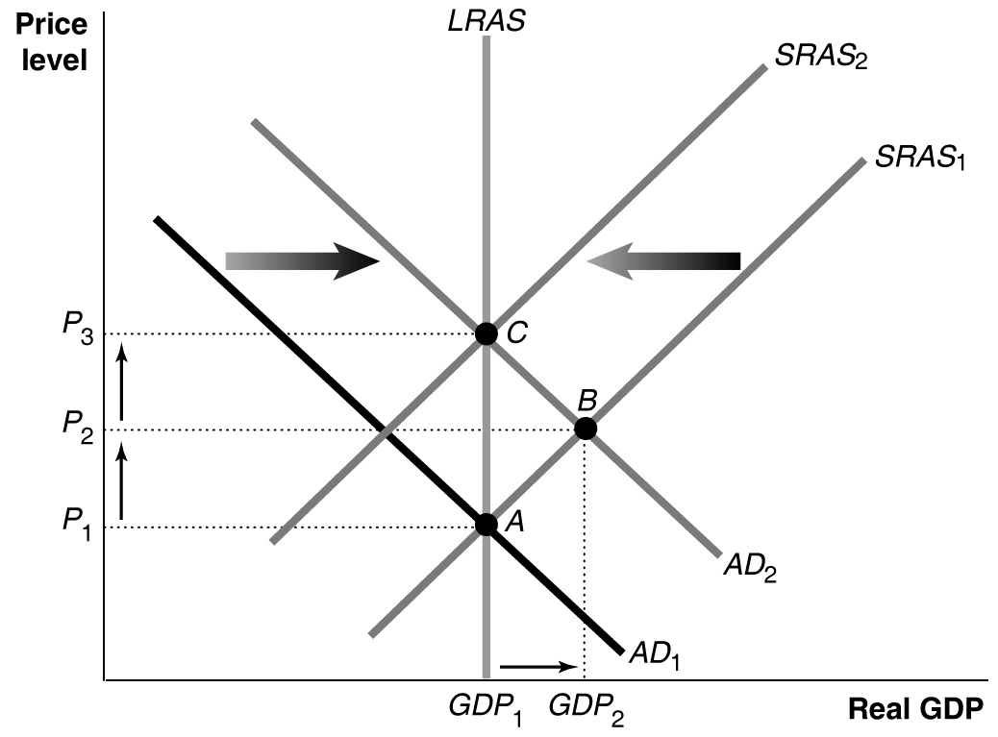

The increase in aggregate demand moves short-run equilibrium from point A to point B with a higher price level and real GDP. As workers and firms will adjust to the price level being higher than they expected, workers will push for higher wages and firms will charge higher prices, causing short-run aggregate supply to shift to the left. In the long run, the economy will be in equilibrium at point C with a higher price level and the same level of real GDP.

b.
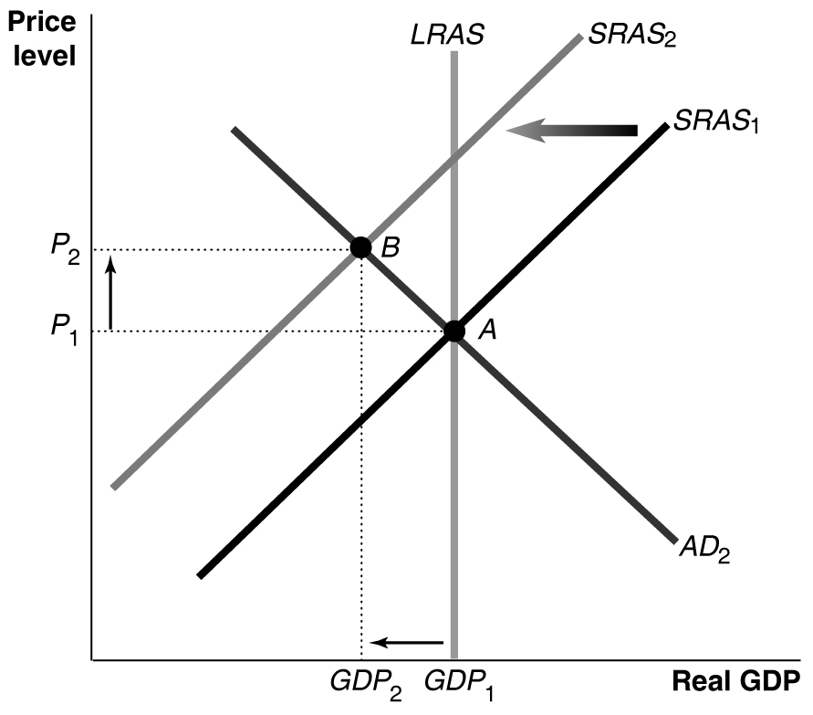

An unexpected increase in the price of an important raw material decreases short-run aggregate supply, moving equilibrium from point A to point B with a higher price level and lower real GDP. The drop in real GDP and the increase in unemployment lead workers to accept lower wages and firms to accept lower prices. Short-run aggregate supply shifts from SRAS₂ back to SRAS₁, and the economy moves from equilibrium at point B back to equilibrium at point A.

3.5 The consequence of some wages and prices being sticky downward is that the economy will return to full employment more quickly when it is initially above full employment, as when AD increases, than when it is initially below full employment, as when AD decreases.

3.6 a. If firms operate beyond their normal capacity and structural and frictional unemployment drop below their normal levels, then actual real GDP can be above potential real GDP.
b. The unemployment rate increased from 1969 to 1970 because the increase in actual real GDP was not as large as the increase in potential real GDP.
c. If the recession was caused by a shift in aggregate demand (which, in fact, it was), the inflation rate is likely to have been lower in 1970 than in 1969. If the recession was caused by a shift in aggregate supply, the inflation rate was likely to have been higher.

3.7 a. Points A and C.
b. Point D represents the short-run equilibrium and point C the long-run equilibrium. Workers and firms will adjust to the price level being higher than they expected. Workers will push for higher wages and firms will charge higher prices, causing short-run aggregate supply to shift to the left until the economy returns to long-run equilibrium at point C.

Learning Objective

Learning Objective 12.4: Use the dynamic aggregate demand and aggregate supply model to analyze macroeconomic conditions.

Review Questions

4.1 In the dynamic model, potential real GDP increases continually, shifting LRAS to the right, aggregate demand shifts to the right during most years, and except during periods when workers and firms expect high rates of inflation, the short-run aggregate supply curve will be shifting to the right.

4.2 Aggregate demand increasing faster than potential real GDP results in inflation. Aggregate demand increasing slower than potential real GDP results in recession, as the economy moves to short-run equilibrium at a level of real GDP that is below potential real GDP.

Problems and Applications

4.3
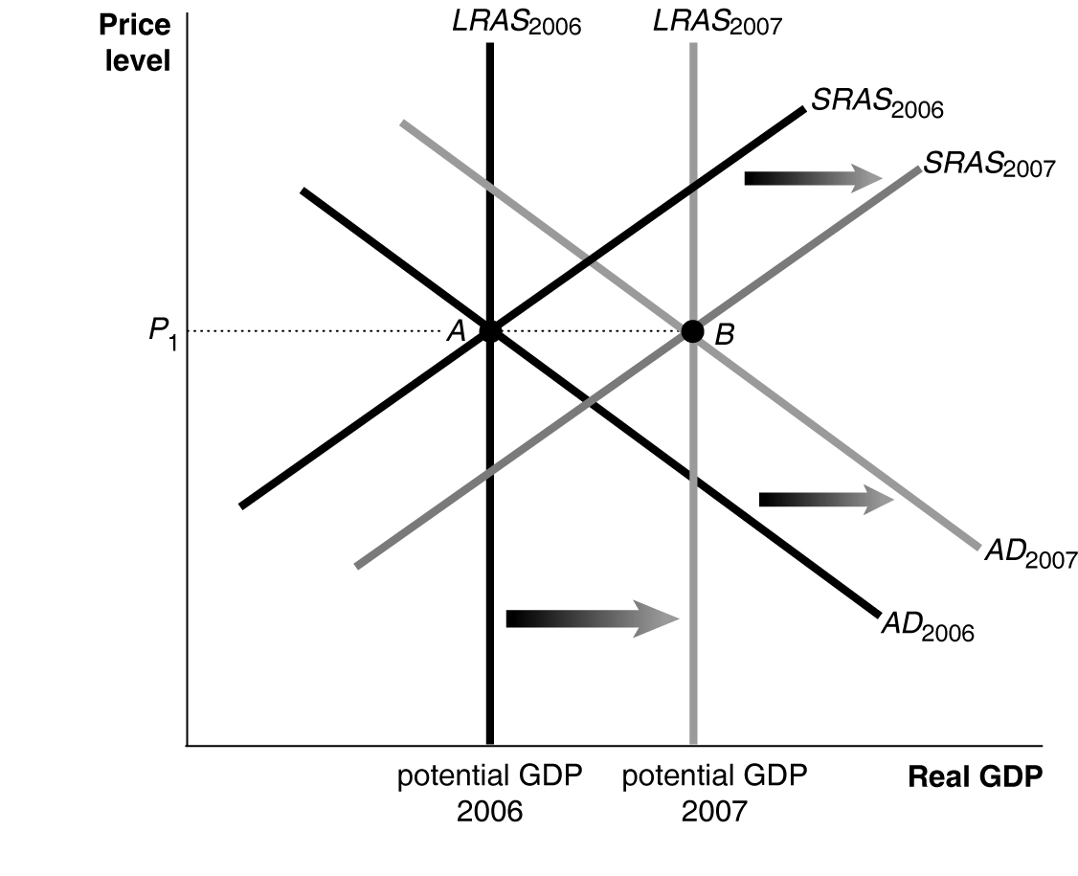

To go from potential real GDP in 2006 to potential real GDP in 2007 without inflation, aggregate demand, long-run aggregate supply, and short-run aggregate supply must all increase – or, shift to the right on the graph – by the same amount.

4.4 a. The price level fell during 1930, which it has not done for an entire year since the 1930s.
b.
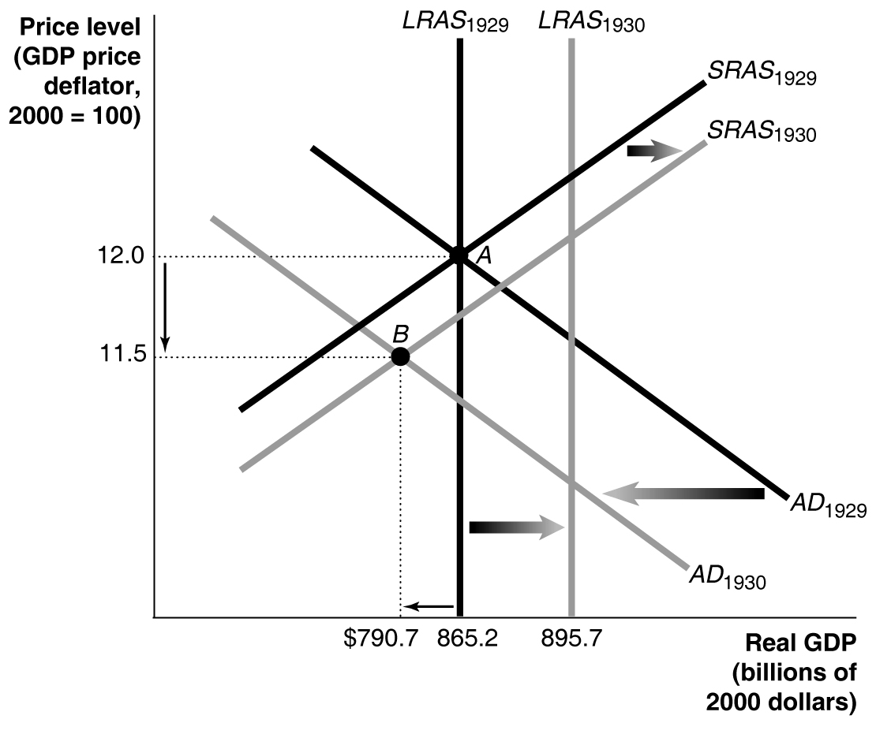

In the graph, as a result of a large decline in aggregate demand, the economy moves from short-run equilibrium at point A to short-run equilibrium at point B.

4.5 No, the inflation rate in 1974 would have equaled 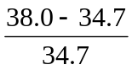x 100 = 9.5%.
The values of the price level of 34.7 in 1974 and 38.0 in 1975 are the values of the GDP deflator for those years with a base year of 2000. That the values are below 100 only indicates that they are for years before the base year.

4.6 In the short run, it is possible that higher productivity means that firms can produce the same amount of goods and services with fewer workers. This relationship, however, does not hold in the long run. In the dynamic aggregate demand and aggregate supply model, higher productivity that shifts the aggregate supply curve to the right also results in higher wages and incomes so that aggregate demand shifts to the right as well. As a result of the shifts in both the aggregate supply and aggregate demand curves, employment will rise.

4.7 a. Growth rate of potential real GDP = 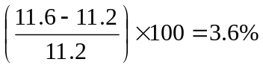
b. The unemployment rate will be higher in Year 2 because the economy is below potential real GDP.
c. Inflation rate in Year 2 = 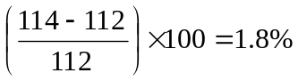
d. Growth rate of real GDP in Year 2 = 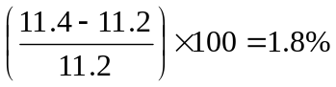

4.8 You should disagree because the statement confuses the inflation rate with the price level. The decline in aggregate demand in 2001 did cause the inflation rate to fall, but the inflation rate was still positive, meaning that the price level increased.

4.9 Many firms still did not feel the need to increase investment spending, particularly on information technology, on which firms had spent heavily in the late 1990s. Uncertainty remained high as the war on terrorism continued with preparations for the invasion of Iraq.

4.10 a. “Business spending” refers to investment spending by businesses on capital goods, office buildings, and machinery.
b. The “Internet and stock market bubbles” refer to the rapid increase in stock prices, including the stock prices of the dot.com companies, in the late 1990s, and the subsequent decline in these stock prices in the early 2000s.
c. The bursting of the bubbles decreased household wealth, which decreased consumption spending. The drop in stock prices also made it harder for businesses to finance investment spending.

4.11 The economy, even though out of the recession, grew slowly in 2002 and was well below potential real GDP. The unemployment rate increased from 4.7 percent in 2001 to 5.8 percent in 2002.

4.12 FedEx’s sales are likely to fluctuate during the business cycle less than the sales of Ford Motor Company and Toll Brothers, but more than the sales of Starbucks and Paramount Pictures. Automobiles and home construction are expensive durable goods that are sensitive to changes in economic conditions. On the other hand, coffee and movies are relatively inexpensive consumer goods that are relatively less sensitive to changes in economic conditions.

4.13
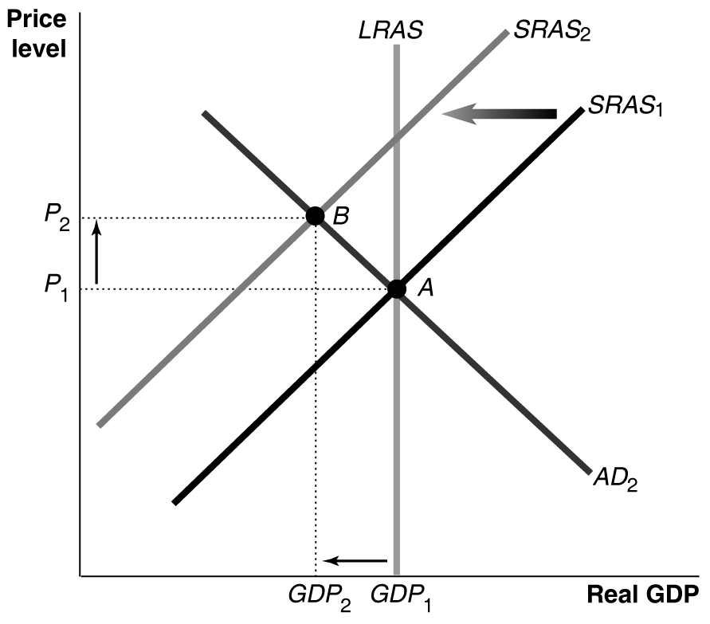

The increase in oil prices decreases SRAS, causing real GDP to decrease and the price level to increase in the short run. Short-run equilibrium moves from point A to point B. In the long run, the increased unemployment leads workers to accept lower wages and firms to accept lower prices, which shifts SRAS back to its initial position. Potential GDP is restored at the initial price level (point A).

